**WHAT ARE THE SYMPTOMS OF EBOLA?**

**Symptoms can start within 2 days of contact with an infected person or body**

* **People in direct contact with sick people are at highest risk**
* **Family members**
* **Healthcare**
* **Highly contagious; many people can quickly become infected**
* **Sick people can spread the disease to others**
* **Ebola is caused by a virus**
* **Neither any vaccine, nor any treatment is available**
* **Causes severe illness with bleeding**

**WHAT IS EBOLA AND HOW DOES IT SPREAD?**

EBOLA

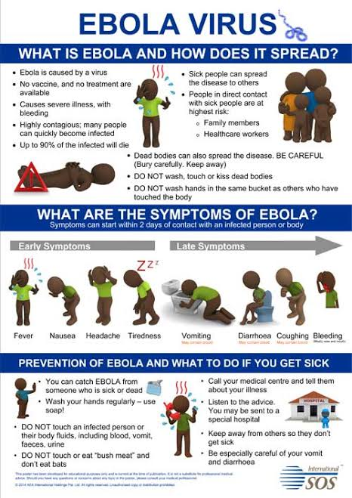

|  |
| --- |
| **Ebola Death Count** |

|  |  |  |
| --- | --- | --- |
| **Country** | **Total cases** | **Total Death** |
| **Guinea** | **3804** | **2536** |
| **Liberia** | **10666** | **4806** |
| **SierraLeonne** | **14122** | **3955** |
| **Nigeria** | **20** | **8** |